**Kickstarter campaigns**

1. **Three conclusions**
   1. Based on the analysis for the successful and for the failed campaign, the more backers the more success. (i.e. Avg 194 vs 18, 3rd Quartile 141 vs 12) There is an obvious trend between the number of backers and the success of the campaign.

Table1) number backer

|  |  |  |
| --- | --- | --- |
| **Backers_count** | **Successful** | **Failed (Unsuccessful)** |
| Mean | 194 | 18 |
| Median | 62 | 4 |
| STD | 844 | 61 |
|  |  |  |
| 1st Q | 29 | 1 |
| 2nd Q | 62 | 4 |
| 3rd Q | 141 | 12 |
| Int Q | 112 | 11 |
| Upper boundary Q3 + (1.5*IQR) | 309 | 28.5 |
| Lower boundary Q1 - (1.5*IQR) | 0 | 0 |

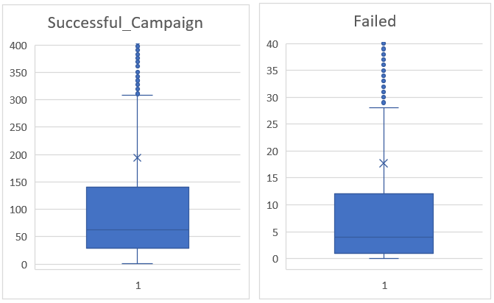

* 1. Goal amount and the success rate has negative trend: the higher goal amount, the less success rate while the failed rate has positive trend. In addition, over $45,000 goal, the success rate drops sharply below 30%.

Table2)

* 1. Music, Theater, Film & Video category has more than 50% of success rate.

Table3)

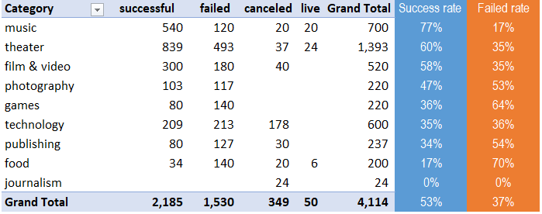

1. **Limitation of the data set**
   1. Definition of success is based on the 100% achievement of the goal. But it might not reflect the reality well. Some campaign achieved 82% of the goal amount, raised over $107K but it classified “Failed”.
   2. “Canceled” and “Live” status campaign doesn’t add much value in the analysis. It might create noise but just added total number of campaigns. Excluding these two statuses might provide more clear analysis.

1. **Other possible tables/graphs**
   1. Top 10 country by its campaign number and each country’s success rate.

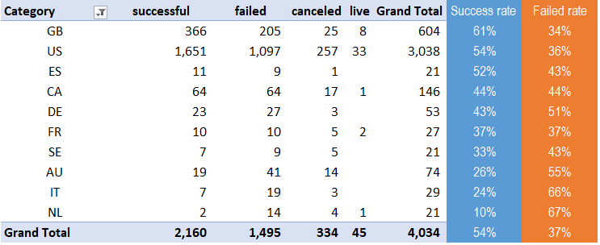

* 1. The success rate trend by year